**IDENTIFICATION OF FAKE PRODUCTS USING BLOCKCHAIN TECHNOLOGY**

**ABSTRACT**

Counterfeiting is a global problem that affects numerous industries and poses significant challenges for consumers, producers, and regulators alike. In recent years, blockchain technology has emerged as a powerful tool to combat the problem of fake products. In this report, we will explore how blockchain technology can be used to identify fake products and prevent them from entering the supply chain.

The global development of the product or branded product always comes with risk factors such as counterfeiting and duplication of product which in turn can affect the company name, reputation, revenue and customer satisfaction. The trading and marketing of counterfeit products is growing at high rates. It affects adversely on the sales, reputation, and profits of the companies and also do poses a fatal threat for the unsuspecting buyers. In order to ensure the identification and traceability of fake goods or products throughout the supply chain and to overcome this phenomenon, a fully functional blockchain system is proposed. Companies need to pay very low transaction fees and they don’t need to worry about the possibility of delivering counterfeit products to end-users. Because of fake products builder, original manufacturers face the biggest problems and huge losses in sense of brand damage as well as revenue loss. To find the originality of the product a functional blockchain technology can be used. Blockchain is a chained arrangement of recorded information that makes it difficult or impossible to modify or hack the framework. Once the product is stored on the network, hash code is generated for that product and it is possible to maintain all transaction records of the product as well as its current owner as a chain created for that product transactions. It will store all the transaction records as blocks in the blockchain. In the proposed system we are assigning a QR code or barcode generated for a particular product created by manufacturer along with all the details of the product. The end customer can scan that QR code to get all information about that product. After scanning the QR code or barcode on the product, the user can identify whether the product is real or fake.

**INTRODUCTION**

When developing a product, various risks such as counterfeiting and replication can threaten the company's reputation, revenue, and customer satisfaction. The proliferation of counterfeit goods in the market poses a significant challenge. To address this issue and ensure effective identification and tracking of fake products, a comprehensive blockchain system is proposed. This solution requires minimal effort from companies, relieving them of concerns related to counterfeit products. Counterfeit items not only result in financial losses for manufacturers but also damage the company's reputation and brand value. Customers often mistake these fake products for genuine ones, leading to misleading reviews based on counterfeit experiences. To tackle this problem, a blockchain-based system can be implemented. Blockchain technology, known for its distributed and decentralized nature, stores data in interconnected blocks within a database. When new data is added, it becomes part of the existing data chain, enhancing the security and traceability of Information The persistent challenge of counterfeiting in product markets poses significant threats to companies, encompassing potential damage to brand reputation, loss of revenue, and diminished customer satisfaction. The rapid proliferation of counterfeit products has become a pervasive issue in the trading and marketing landscape, necessitating innovative solutions for identification and mitigation.

1.2

In response to this pressing problem, the proposition of a fully functional blockchain system emerges as a promising avenue. This technological framework, rooted in decentralization and distributed ledger principles, offers a robust mechanism for addressing the menace of counterfeiting. By utilizing blockchain, companies can substantially enhance their ability to identify and track fraudulent products, instilling a greater level of confidence and security in the market. The implementation of a blockchain-based system entails minimal effort on the part of companies, providing them with an efficient means to safeguard their products and brand integrity. This transformative approach mitigates the concerns associated with counterfeit products, offering a comprehensive solution that not only protects against financial losses but also preserves the invaluable asset of brand reputation. Counterfeit products, often indistinguishable from genuine ones, can mislead consumers into submitting reviews based on inaccurate perceptions. This misleading feedback further exacerbates the challenge faced by manufacturers, necessitating a proactive and technologically advanced strategy.

The blockchain, through its decentralized architecture and secure data storage in interconnected blocks, becomes a reliable ally in this battle against counterfeiting As new data is added to the blockchain, it seamlessly integrates with the existing chain of information, creating an immutable and transparent record. This enhances traceability, ensuring that each product's provenance is accurately documented throughout its lifecycle. In essence, the blockchain serves as a digital ledger of trust, offering a solution that not only addresses the immediate problem of counterfeiting but also instills confidence in consumers, thereby fostering a more resilient and secure market environment.

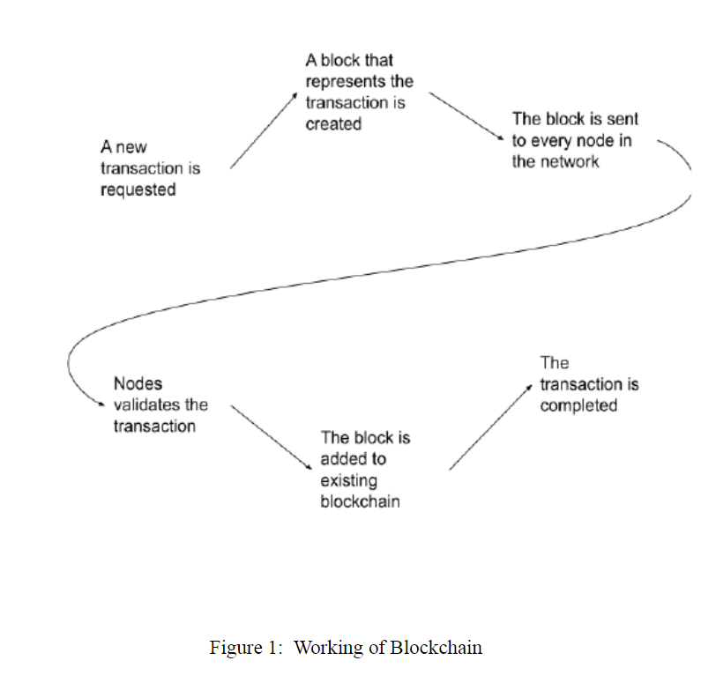

**REVIEW OF LITERATURE**

Satoshi Nakamoto [2] elucidated the concept of a purely peer-to-peer electronic cash system, envisioning online payments that could be directly transmitted from one party to another without reliance on financial intermediaries. A. Funde [3] delved into the application of IPFS (Inter Planetary File System), a Distributed Web technology, for managing product ownership. The fundamental security of a blockchain system lies in the hash algorithm [4]. N. Alzahrani [5] introduced the concept of block-supply chain, a novel decentralized supply chain leveraging blockchain and Near Field Communication (NFC) to detect counterfeiting attacks. Si Chen and team [6] explored the integration of blockchain technology to enhance supply chain quality management, presenting a framework for blockchain-based quality management in the supply chain.

The QR code, short for "Quick Response," is a 2D matrix code designed to facilitate the storage of a substantial amount of data compared to traditional 1D barcodes. Its key attributes include high data storage capacity, rapid scanning, omnidirectional readability, error correction, and various versions [7]. Smart contracts, articulated as self-executing agreements among parties, exist as program codes across a distributed, decentralized blockchain network. They enable transactions between untrusted parties without reliance on a central authority. Early contributions to smart contract development were made by Szabo and Miller [8].

**PROPOSED METHODOLOGY**

Given the escalating prevalence of counterfeit products globally, it becomes imperative to construct a comprehensive application system aimed at discerning and identifying these deceptive products. This document outlines the proposal for such a system, putting forth the notion of a full-fledged application designed to effectively identify and combat the proliferation of counterfeit products in the market. We will use QR codes to verify the products and add information about the product. And for storing the data of the product we need to use a system that does not allow anyone to change the existing data, this can be achieved by blockchain technology. So in this proposed system, we are using blockchain, and QR codes to detect fake products.

**SYSTEM MODEL**

In the proposed system's model, the implementation of blockchain is executed using Ganache, a personal software tailored for this purpose. Ganache facilitates the development of a blockchain network dedicated to managing transactions effectively. To interact with the Ethereum blockchain, Ganache serves as a vital component. Metamask, functioning as a web browser extension, acts as the intermediary between the web page and the blockchain, enhancing the user interface for seamless interaction.

For the development of the web page, the system utilizes node.js, a JavaScript runtime, while the creation of blockchain smart contracts is accomplished using the Solidity programming language. This comprehensive integration of technologies establishes a robust framework for the detection of counterfeit products, combining the security features of blockchain with the practicality of QR codes to create a reliable and transparent system.

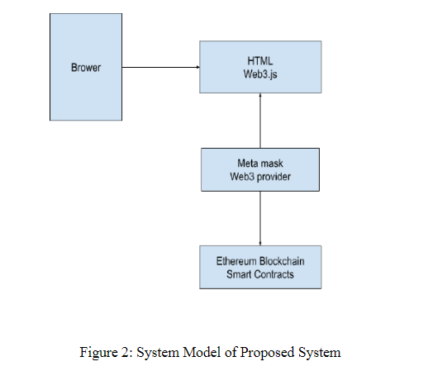

**TOOLS REQUIREMENT**

**Ganache**: Ganache is a software suite that is used to set up your personal ethereum blockchain. It is used to deploy your blockchain to the network. It helps to stimulate the ethereum blockchain so that you can interact with your smart contracts in the blockchain.

**Metamask:** Metamask is a web browser extension and it acts as an interface between the browser and the ethereum blockchain and it helps the user to use their ethereum blockchain wallet.

**Truffle Suite:** Truffle is a framework that helps us to set up an environment to write smart contracts in blockchain.

**Nodejs:** Nodejs is a framework that is used to develop the web page of the website.

**Solidity:** Solidity is a programming language. It is used to write smart contracts in blockchain.

**Flow of the Proposed System:**

**Stage 1:** Product Registration Process:

The manufacturer adds the product to the blockchain database.

A QR code is assigned to the product for adding new data.

**Stage 2:** Distributor Chains:

The manufacturer ships the product to the distributor.

Upon receiving, the distributor scans the QR code and adds new details to the network, including product ownership, timestamp, and date.

**Stage 3:** Retailer Chains:

The retailer receives the product from the distributor.

The retailer scans the QR code assigned to the product.

**Stage 4:** End User:

The customer, at the end of the chain, takes the product.

The customer goes to the website, uploads the QR code, and gains access to all product details from the manufacturer to the last retailer.

This system effectively maintains the ownership status of a product, starting with the manufacturer, and records the history of ownership. Each step in the supply chain, from manufacturer to distributor to retailer, adds new information to the blockchain, ensuring transparency and allowing end-users to verify the authenticity of the product before making a purchase decision.

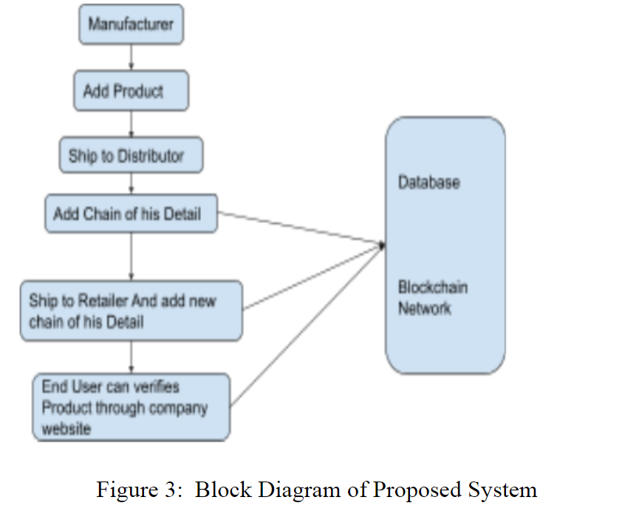

**RESULT AND DISCUSSION**

The proposed system allows both manufacturers and suppliers to interact with the system to add their respective block containing the transaction details to blockchain without modifying other’s block. The contracts for the manufacturer and supplier block are written using solidity. Since the code is running on local network ganache have been used for local testing. The host”127.0.0.1”, and port 7545 is configured in true-config.js file. The contracts are then compiled and deployed using true. Migrations files are created for deployment. Migrations are files that help us to deploy contracts on an ethereum blockchain network. The interface is created using React. To allow interacting with ethereum blockchain Web3.js library is used which is used to perform actions like sending ether, confirming transactions reading and writing data from smart contracts. Metamask is installed on a browser which is a wallet to interact with ethereum blockchain, to allow accessing ethereum wallet through a browser. Accounts from ganache are imported into the metamask. To add supplier and manufacturer blocks they have to confirm the transactions using their account using metamask wallet which is connected using Web3.js.The end-user can then check the supply chain by scanning the QR code to check the product integrity.

**CONCLUSION**

n this paper, we have proposed a fully functional application

that helps users to detect whether the product is fake or real.

The manufacturer for the first time stored the detail of the

product in the blockchain and generated an embedded QR

code to add other details by other parties. At the time of

receiving the product, other parties will add their details of

ownership of the product. In the end, the customer can scan

the QR code and can check the history of the product, and

decide whether the product is genuine o

In this paper, we have proposed a fully functional application that helps users to identify whether the product is counterfeit or real. The manufacturer for the first time stored the detail of the product in the blockchain and generated an embedded QR code to add other details by other parties. At the time of receiving the product, other parties will add their details of ownership of the product. In the end, the customer can scan the QR code and can check the history of the product, and decide whether the product is genuine of the formulation of a wholly operative application capable of ascertaining the legitimacy of products emerges as a pivotal contribution to the expansion and safeguarding of the retail market. This groundbreaking solution not only ensures the end user's confidence in procuring bona fide, branded commodities but also plays a vital role in upholding the reputation and corporate value for manufacturers.

In the contemporary realm of technological progressions, blockchain distinguishes itself as a pivotal player in providing heightened security and functionality for stored data. The assimilation of a blockchain-grounded application emerges as a transformative force, acting as a life preserver for both patrons and manufacturers alike. By harnessing the decentralized and secure characteristics of blockchain technology, this application becomes a potent instrument in countering spurious products, nurturing trust, and fortifying the integrity of the retail milieu.

Fundamentally, the adoption of blockchain-rooted applications signifies a proactive and efficacious measure in the ongoing skirmish against deceptive practices. Its capability to establish an unalterable record of product authenticity not only heightens consumer assurance but also acts as a bulwark for manufacturers, conserving their corporate standing and intrinsic value. As we navigate the complexities of the contemporary technological landscape, it becomes increasingly apparent that blockchain serves as a linchpin in ensuring the authenticity, security, and sustained expansion of the retail sector.

Therefore, derived from the aforementioned discourse, it can be asserted that crafting a comprehensively operational application capable of discerning the genuineness of products significantly contributes to the flourishing of the retail market. This inventive solution not only in stills confidence in end users regarding the authenticity of their purchases but also functions as a crucial element in upholding the esteemed reputation and corporate value for manufacturers.

In the present-day panorama of technological advancements, blockchain takes center stage as an integral provider of augmented security and functionality for stored data. The integration of a blockchain-centric application emerges as a revolutionary force, acting as a life-saver for consumers and manufacturers alike. Leveraging the decentralized and secure features inherent in blockchain technology, this application becomes a potent tool in thwarting fraudulent products, nurturing trust, and reinforcing the integrity of the retail ecosystem.

Essentially, the incorporation of blockchain-based applications denotes a proactive and effective strategy in the ongoing battle against deceptive practices. Its capacity to establish an immutable record of product authenticity not only enhances consumer confidence but also functions as a shield for manufacturers, preserving their corporate reputation and intrinsic value. In navigating the intricacies of the contemporary technological landscape, it becomes increasingly evident that blockchain serves as a cornerstone in guaranteeing the authenticity, security, and continual growth of the retail sector.

**SAMPLE AND REFERENCES**

Aini, Qurotul, et al. "Embedding a blockchain technology

pattern into the QR code for an authentication certificate."

Jurnal Online Informatika 5.2 (2020): 239-244.

[8] Xie, Shundao, et al. "Two-stage te

[1] Aini, Qurotul, et al. "Embedding a blockchain technologypattern into the QR code for an authentication certificate."Jurnal Online Informatika 5.2 (2020): 239-244.

[2]Dursun, Taner, et al. "Blockchain Technology for SupplyChain Management." Global Joint Conference onIndustrial Engineering and Its Application Areas.Springer, Cham, 2020.

[3] C. Shaik, Computer Science & Engineering: An International Journal (CSEIJ) 11 (2021).

[4] M.A. Benatia, D. Baudry, A. Louis, Journal of Ambient Intelligence and Humanized Computing pp. 1–10 (2020) [11] G. Khalil, R. Doss, M. Chowdhury, IEEE Access 8, 47952 (2020).

[5] M.A. Habib, M.B. Sardar, S. Jabbar, C.N. Faisal, N. Mahmood, M. Ahmad, Blockchain-based supply chain for the automation of transaction process.

**REFERENCE PAPER**

Blockchain Based Fake Item Identification System

TY - BOOK

AU - Saxena, Nitin

AU - Singh, Harikesh

AU - Singh, Pranav

AU - Agarwal, Nimish

AU - Tyagi, Vishu

PY - 2023/05/19

SP - 1

EP - 6

T1 - Blockchain Based Fake Item Identification System

VL -

DO - 10.1109/GlobConET56651.2023.10149933

**Name and Signature of Students**

**Name and Signature of Mentor**